**Boundary value analysis** and **Equivalence Class Partitioning** both are test case design techniques in black box testing.

 Example of Equivalence Class Partitioning?

* A text field permits only numeric characters
* Length must be 6-10 characters long

Partition according to the requirement should be like this:

**0 1 2 3 4 5 | 6 7 8 9 10 | 11 12 13 14**

**INVALID | VALID | INVALID**

While evaluating Equivalence partitioning, values in all partitions are equivalent that’s why 0-5 are equivalent, 6 – 10 are equivalent and 11- 14 are equivalent.

At the time of testing, test 4 and 12 as invalid values and 7 as valid one.

It is easy to test input ranges 6–10 but harder to test input ranges 2-600. Testing will be easy in the case of lesser test cases but you should be very careful. Assuming, valid input is 7. That means, you belief that the developer coded the correct valid range (6-10).

**What is Boundary value analysis:**

**Boundary value analysis** is a test case design technique to test boundary value between partitions (both valid boundary partition and invalid boundary partition).

Using Boundary Value Analysis technique tester creates test cases for required input field. For example; an Address text box which allows maximum 500 characters. So, writing test cases for each character once will be very difficult so that will choose boundary value analysis.

Example for Boundary Value Analysis:

**Example 1**

Suppose you have very important tool at office, accepts valid User Name and Password field to work on that tool, and accepts minimum 8 characters and maximum 12 characters. Valid range 8-12, Invalid range 7 or less than 7 and Invalid range 13 or more than 13.

[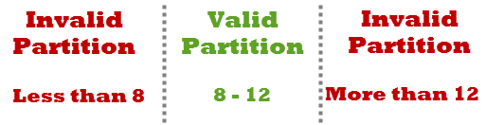](https://www.softwaretestingclass.com/wp-content/uploads/2013/11/example-for-boundary-value-analysis1.png)

Write Test Cases for Valid partition value, Invalid partition value and exact boundary value.

* Test Cases 1: Consider password length less than 8.
* Test Cases 2: Consider password of length exactly 8.
* Test Cases 3: Consider password of length between 9 and 11.
* Test Cases 4: Consider password of length exactly 12.
* Test Cases 5: Consider password of length more than 12.

**Example 2**

Test cases for the application whose input box accepts numbers between 1-1000. Valid range 1-1000, Invalid range 0 and Invalid range 1001 or more.

[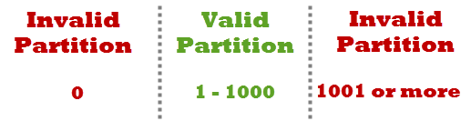](https://www.softwaretestingclass.com/wp-content/uploads/2013/11/example-for-boundary-value-analysis2.png)

Write Test Cases for Valid partition value, Invalid partition value and exact boundary value.

* Test Cases 1: Consider test data exactly as the input boundaries of input domain i.e. values 1   and 1000.
* Test Cases 2: Consider test data with values just below the extreme edges of input domains i.e. values 0 and 999.
* Test Cases 3: Consider test data with values just above the extreme edges of input domain i.e. values 2 and 1001.